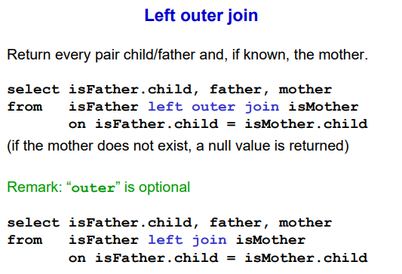

NOTE (from last exercise): if we have only the mother or the father and we miss a parent in the database then the individual is not present in the output table. We would like to have ‘Marco’ ‘Adam’ ‘Null’ if there is only one parent in the database.

⟹ use left outer join. It puts two table together but it will use the left table as truths, for every row in the left table if you can find a matching row in the right we report the combination as usual. But if we do not find any match with the right it will still report in the outcome the content of the table of the left and for the attributes on the right we will have ‘Null’.

NOTE: we can right left join rather than left other join

EXAMPLE OLD:
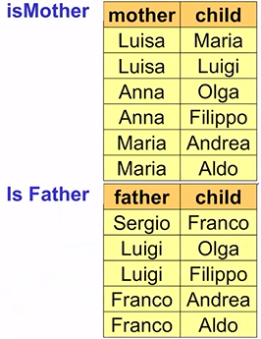
(normal) matching isMother and isFather with the constraint of the child name. We will return no match between Luisa, Maria and the isFather table (because the child Maria is not present in any of isFather tuples).

⟹ with left join the output with no match will have Luisa, Maria, Null.

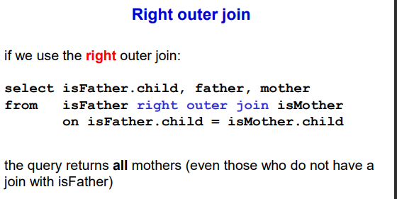
We can also use the right outer join.

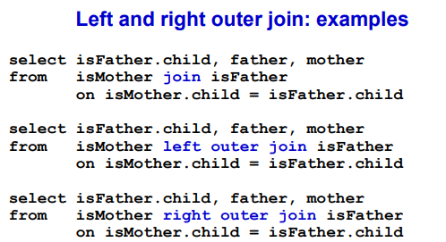

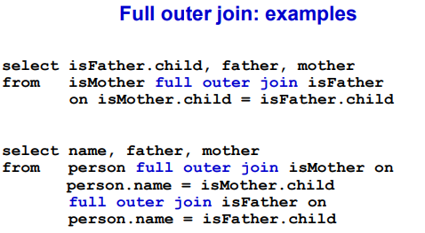
FULL OUTER JOIN (is like doing left and right outer join together)

We can have Null for the attributes for the first and second table

A | B |  | C | D
1 | 2 |  | 3 | 9
5 | 6 |  | 6 | 7

select *
from R join S on R.B = S.C
OUTCOME:
A | B | C | D
5 | 6 | 6 | 7

select *
from R left join S on R.B = S.C
OUTCOME
A | B | C | D
1 | 2 | 2 | Null
5 | 6 | 6 | 7

select *
from R right join S on R.B = S.C
OUTCOME
A | B | C | D
Null | 3 | 3 | 9
5 | 6 | 6 | 7

select *
from R full join S on R.B = S.C
OUTCOME:
A | B | C | D
1 | 2 | 2 | Null
Null | 3 | 3 | 9
5 | 6 | 6 | 7

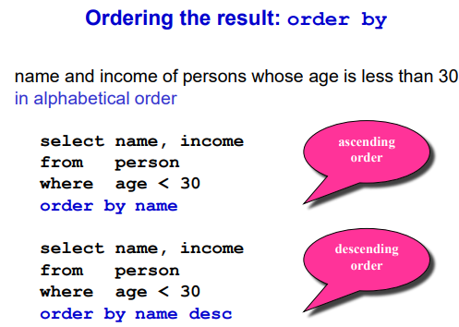

ORDER BY
operator that is applied on the final result of the query. Does not affect the construct of the query. Specify one or more attributes separated by comma.

by default is increasing order: from small to highest number (or alphabetical order) or for date from older to more recent.

To order for more than one attribute we first order the rows according to the name and whenever you have a clash you order according to income.

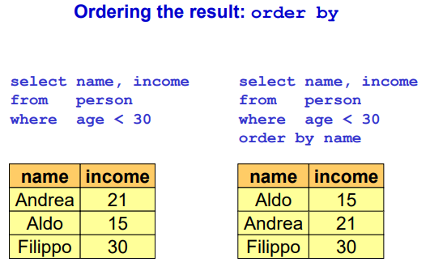
without the order by the output might be in order of the tuples in the table.
If you order by the name you guarantee that the result will be order according by the name

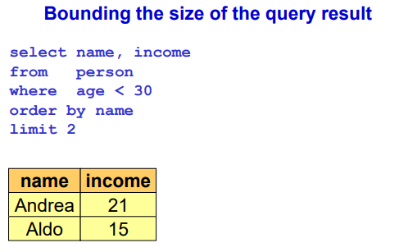
Use to limit the amount of rows in the result. It is applied after the order. The limit is always by order (but order is not mandatory).

(NOTE: the slide is wrong, aldo should be before andrea)

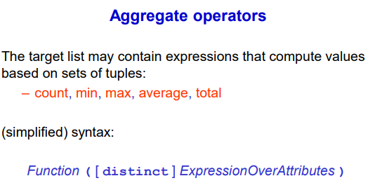
Arithmetic operations. We use aggregate operators that aggregate many elements.
NOTE: average is written avg, total is written as sum

- min: will give m minimum element,
- …

- average only on numerical value

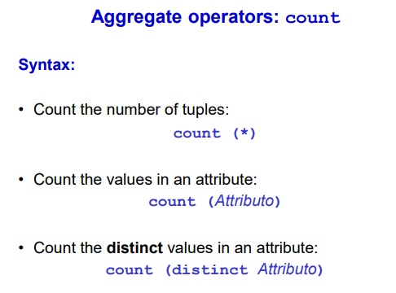
we want to know how many people are in a table

select *
from person

to apply count operator we write
select count(*)
from person

count can have * or an attribute (like a name, count the non null elements in the attribute).

We can also have count (distinct attributes)

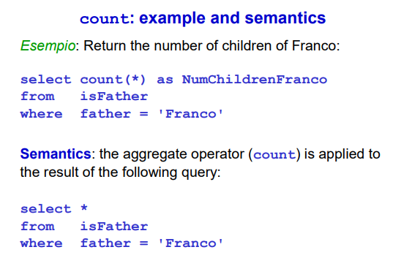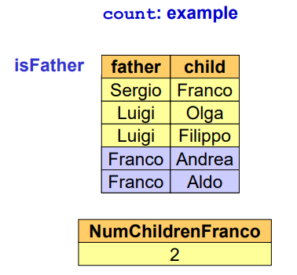

count all the people that have as father someone named franco.

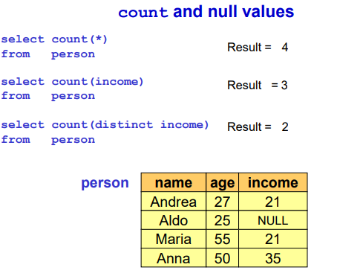
With null values:
select count(*)
from person
⟹ count all the people, no matter how the look like. We get 4 tuples

select count(income)
from person
⟹ ignores null values and count duplicates as well

select count (distinct income)
from person
⟹ ignores null values and ignore duplicates

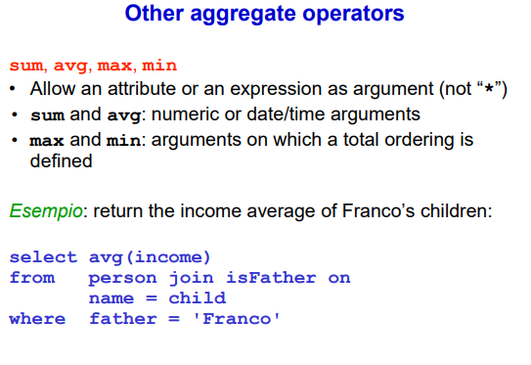

Take a single attribute or an expression (not “*”).

Sum and avg only for numeric or date/time

NOTE: the result is only table with one column containing the result and the name.

Max and min for ordering also.

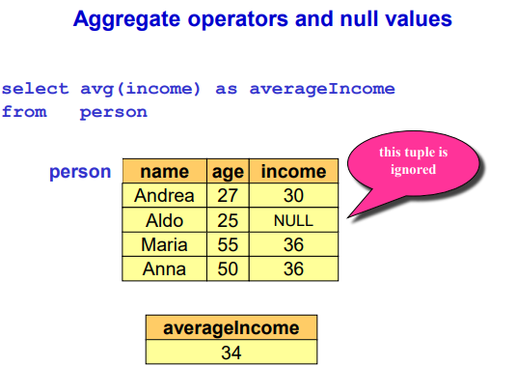
first pick person table and in the income column will compute the average but ignore the NULL.

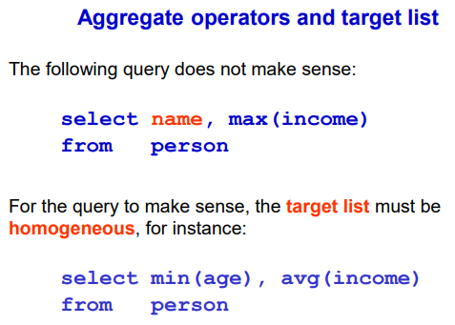

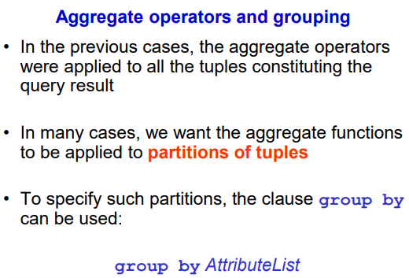

usually compute aggregate operators not on the entire table but only on specific parts (like avoid average income of all people, more common to do average income of people with less than 30 years).

Want many averages for many interesting groups.

⟹ use group by operator. This says that when we compute the results we group them according to a condition. (like sorting by age), the only guarantee is that they are grouped (not in the correct order).

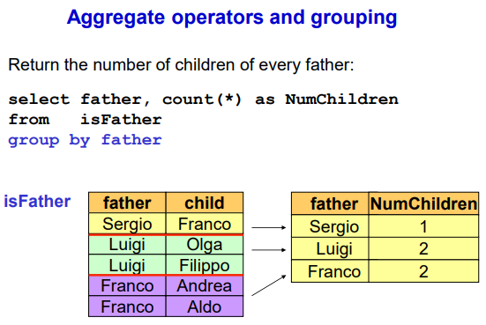
I want to show how many children a father has.
group by father ⟹ group first by Serio, then Luigi and then Franco, but order is not guaranteed to be correct

group the results associated by a common value in the attribute

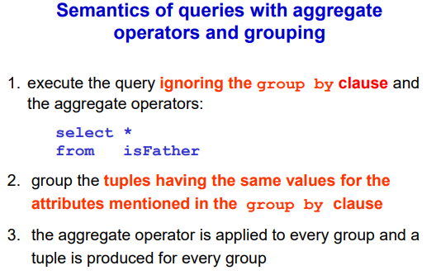

take result of query and group results and one couple is used for every group

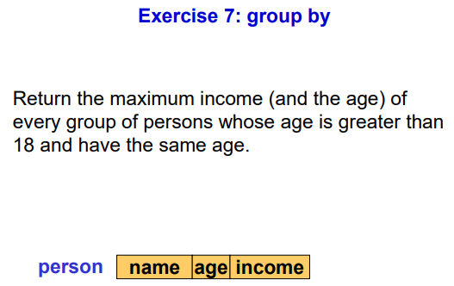

select max(income), age
from person
where age>18
group by age

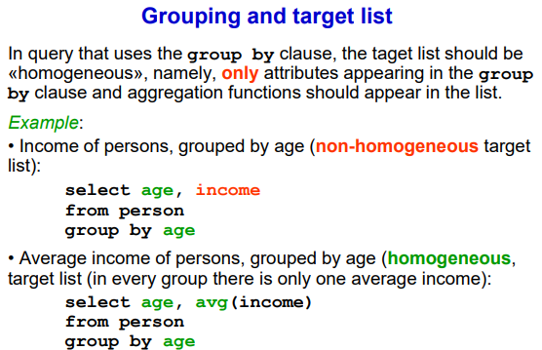

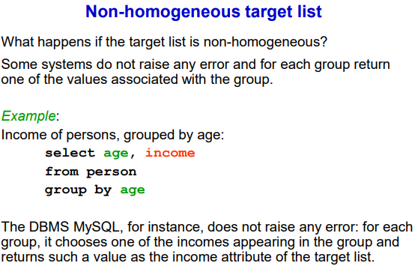

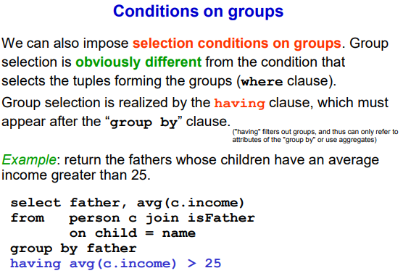

Having operator: it is applied after the group by (is not the where!!!) and it is applied to one group at time. Having will look at each group (aka tuples that share the same attribute)

⟹ the goal of having is not to filter out single tuples but to filter out groups

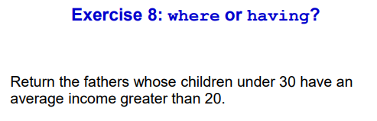
select father
from person, father
where father.child = person.name and person.age < 30
group by father
having avg(person.income) > 20
